**Face Mask Detection**

**Overview**

**What**

1. It is a Computer Vision Application which can detect whether a person wear a mask or not and then store their data who are not wearing the mask.
2. This application can get data from various sources such as IP Camera, webcam and online video etc.
3. This is a web application which can be accessed over a LAN.
4. The IP camera is a wireless surveillance camera which can send footage to the wi-fi network to which it is connected, if the computer which contains the application is also connected with the same wi-fi network then we will be able to work on that footage data into our project and can detect mask.

**Why**

1. This application can be used in many cities such as Hospitals, Research Labs, Polluted areas and many other places where respiratory infectious possibility can be occurred.
2. This kind of project shows Machine Learning knowledge, Programming skills and web development skills which can be very useful for resume perspective.
3. This project shows how you can solve real world problem with your knowledge.

**How**

1. **Backend**

|  |  |
| --- | --- |
| **Connection with IP camera** | OpenCV |
| **Face Detection** | OpenCV |
| **Mask Detection** | Keras, Numpy |
| **Save Data** | OpenCV |

1. **Frontend**

|  |  |
| --- | --- |
| **Web Application** | Streamlit |

**OpenCV**

1. Installing OpenCV package.

|  |
| --- |
| pip install opencv-python |

1. Code for OpenCV

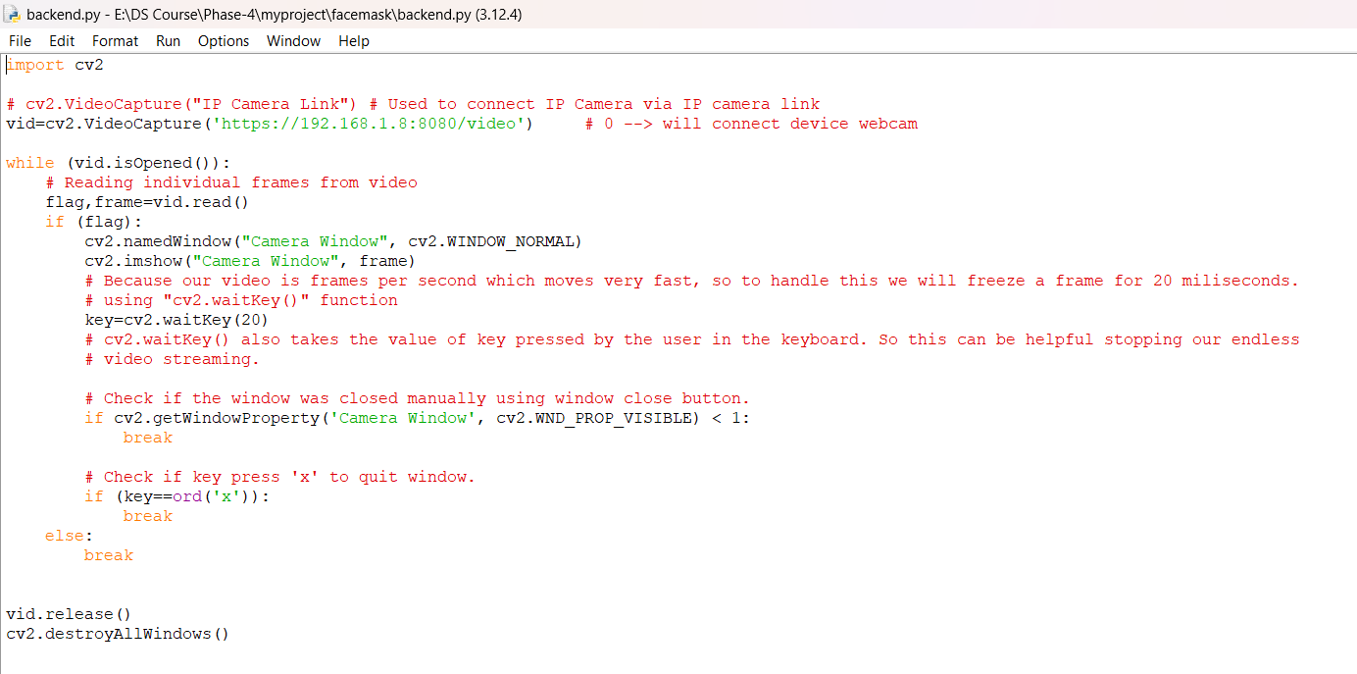

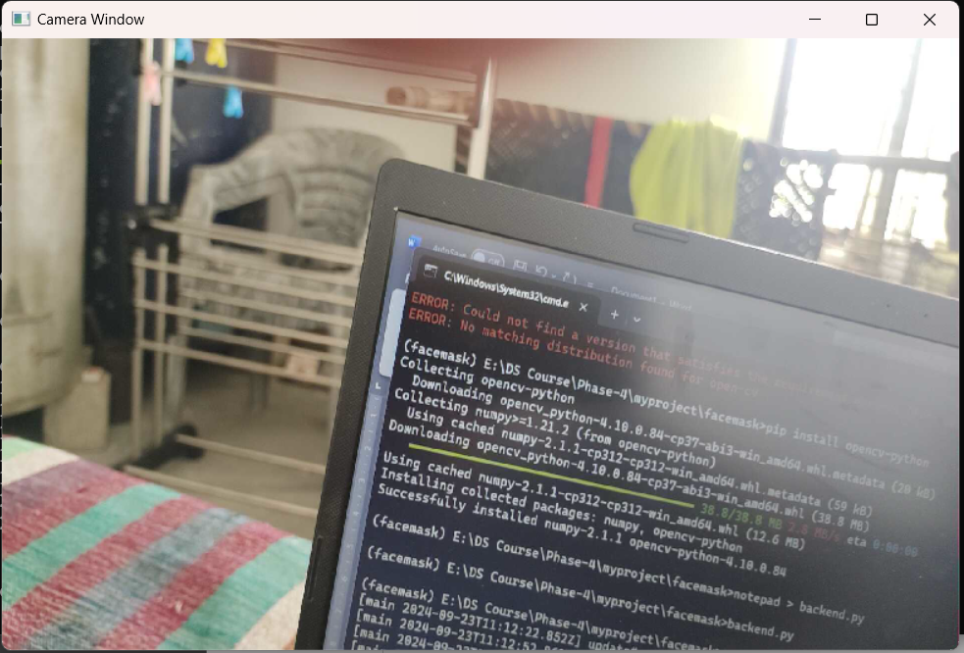

1. Code for face detection

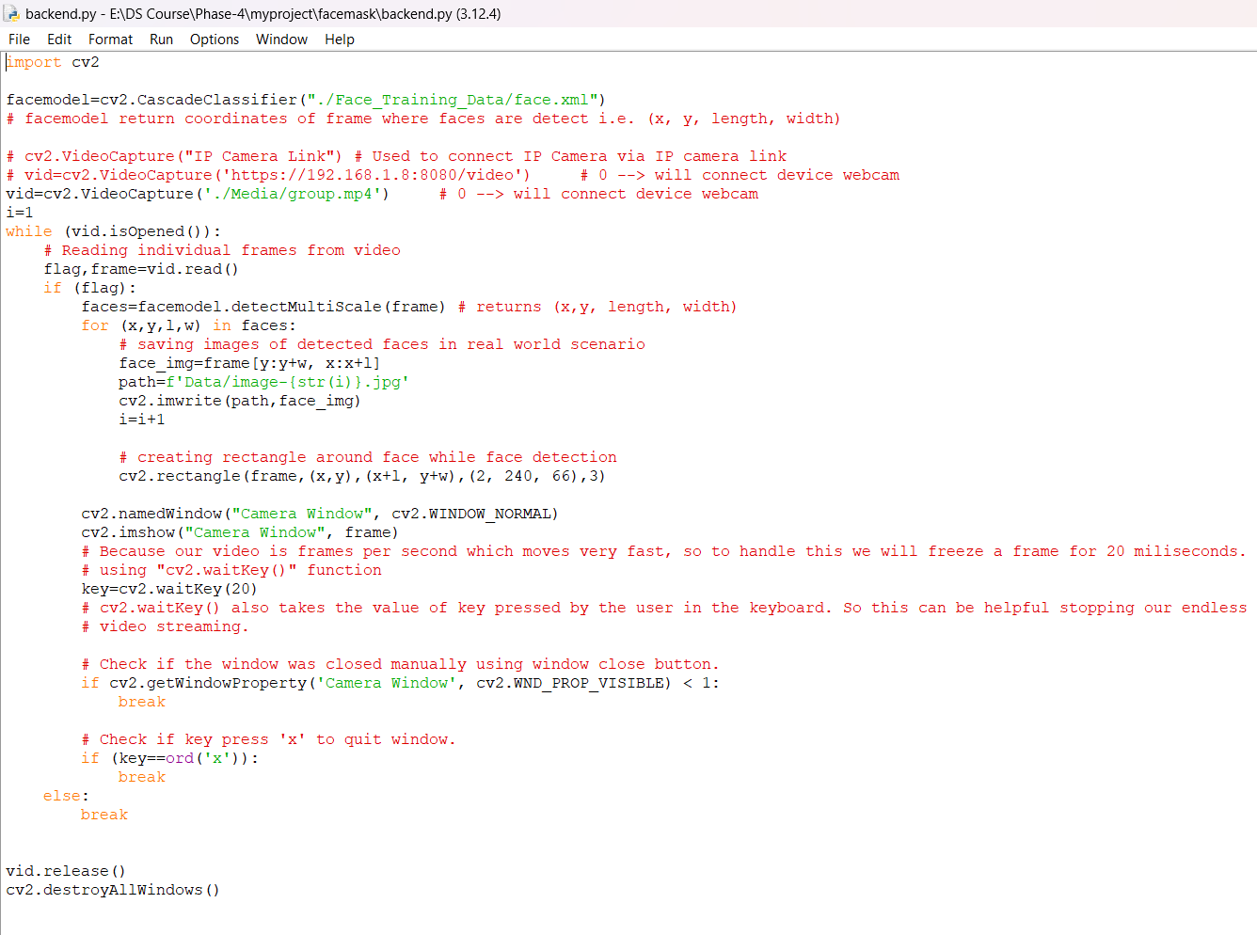

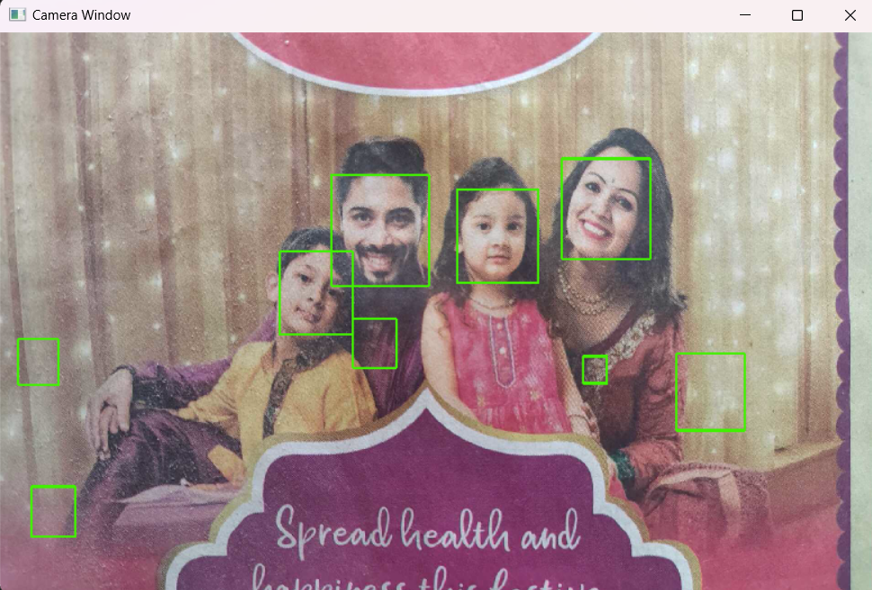

1. Training Model for Mask Detection

* Installing packages:
  + Pillow
  + Scipy
  + Tensorflow

|  |
| --- |
| pip install pillow scipy tensorflow |

* Training and Saving CNN Model

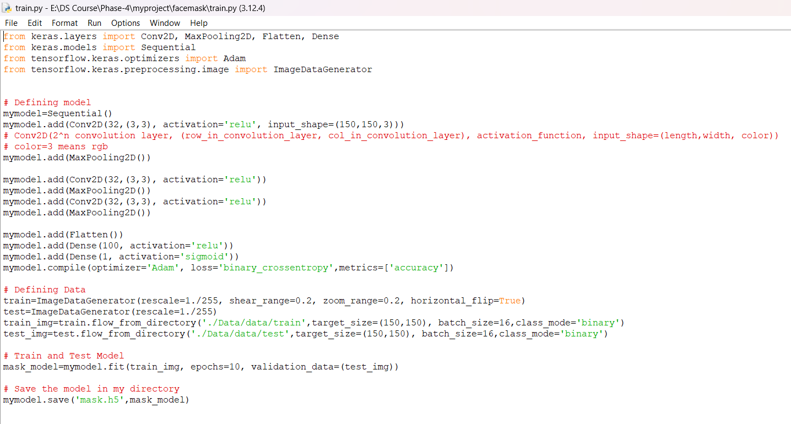

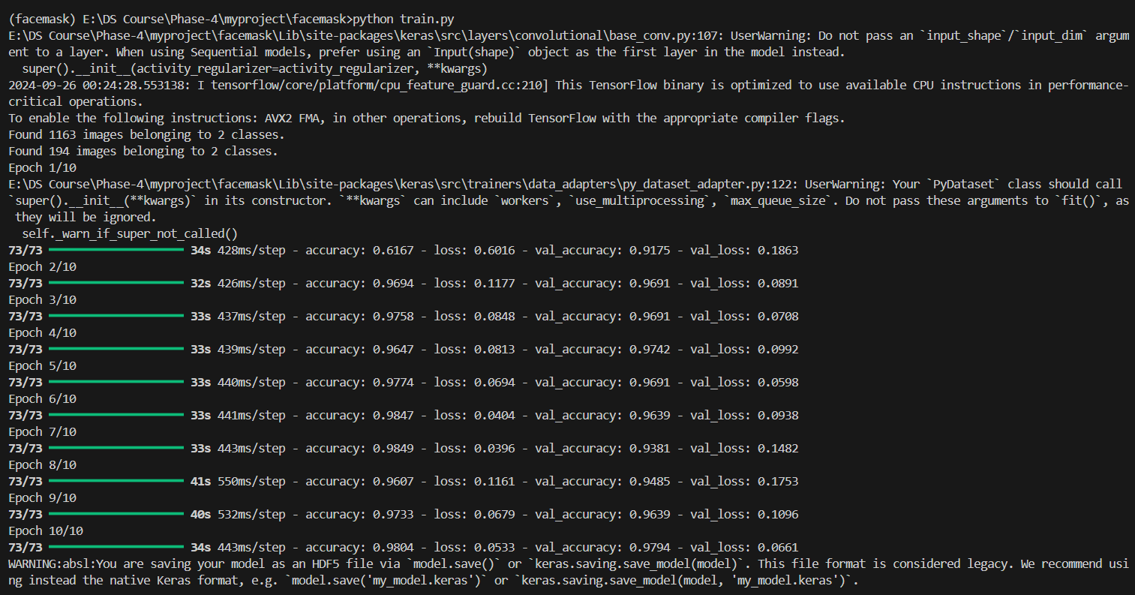

* Detecting Mask from video

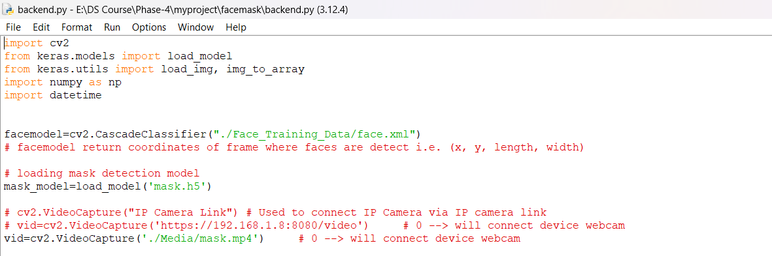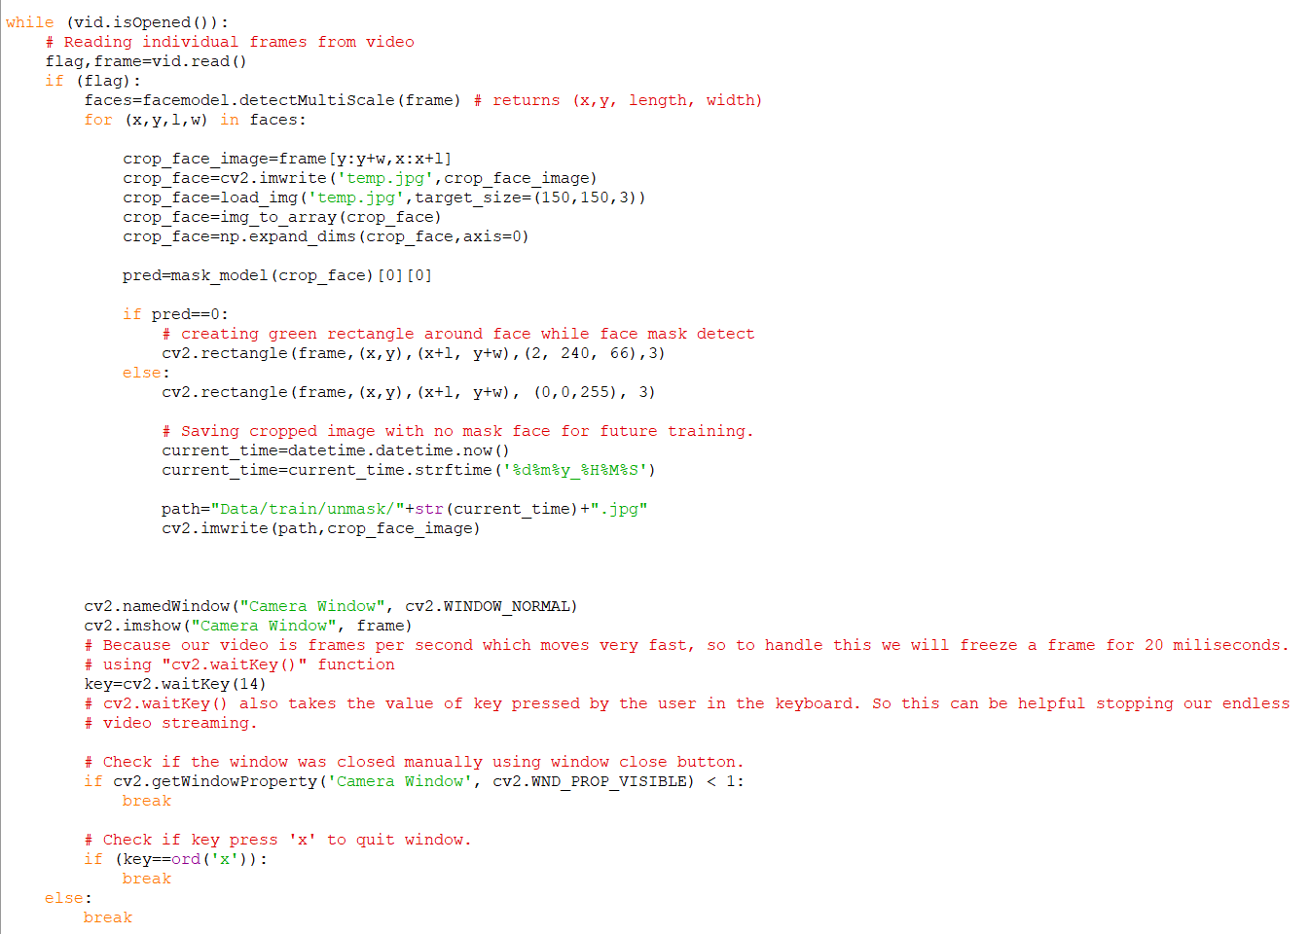

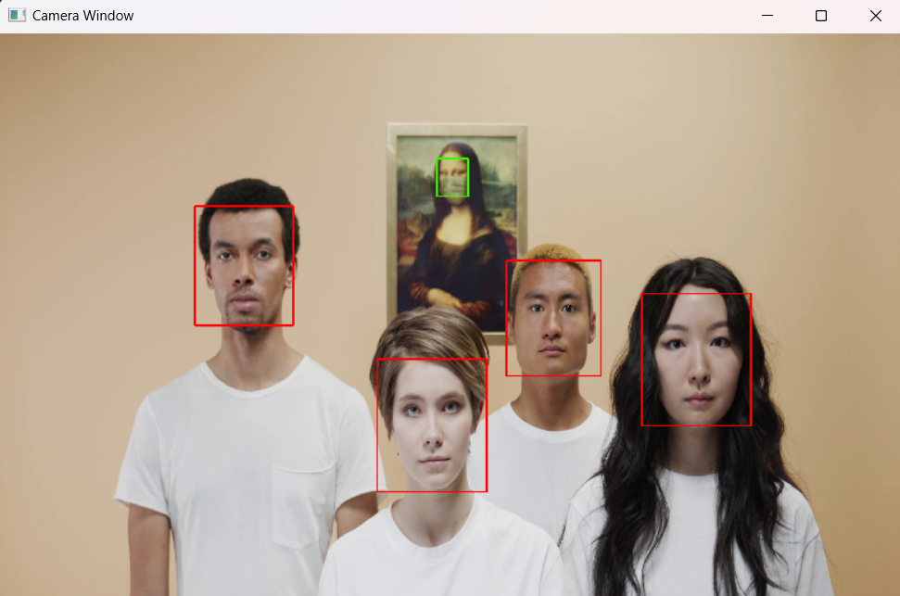

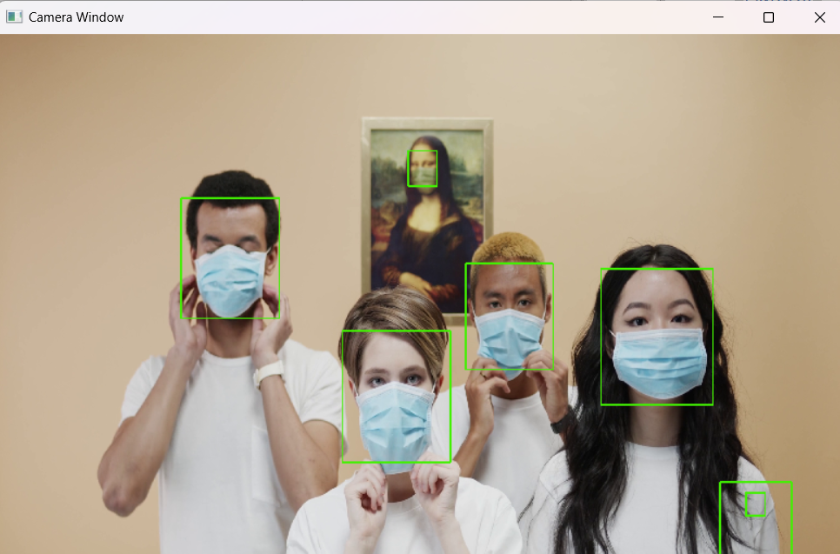

1. Creating Frontend for Face Mask Detection application.

* Code Review

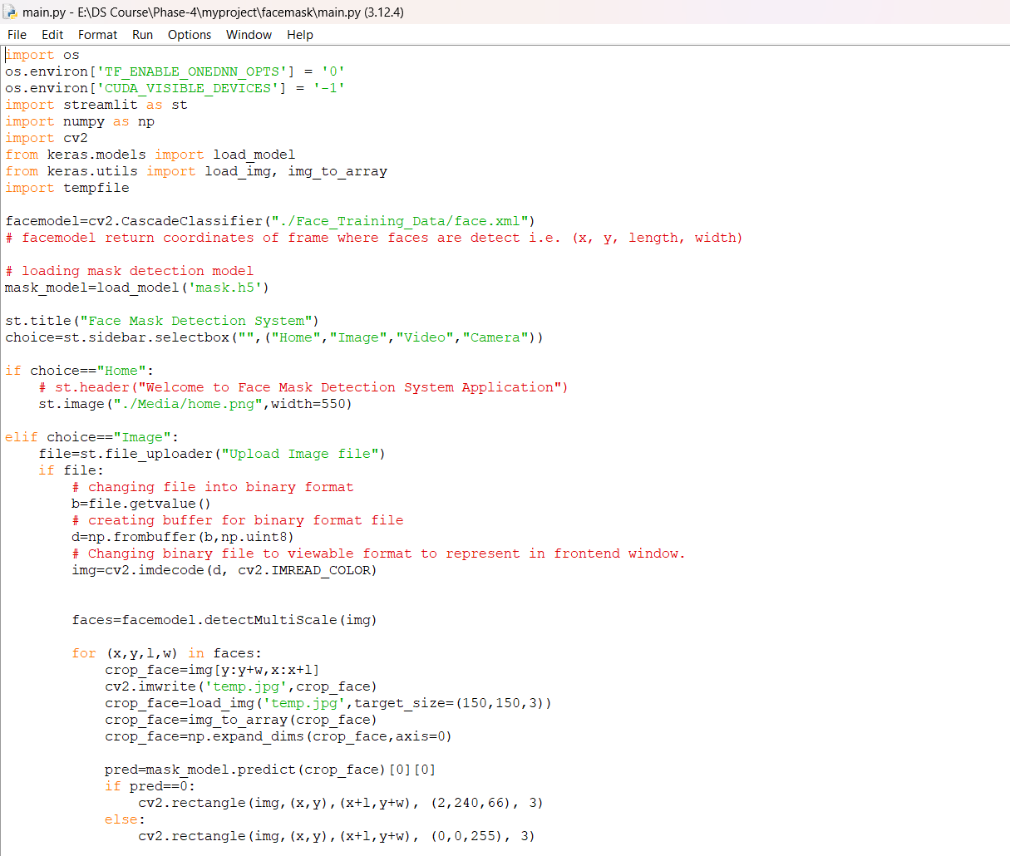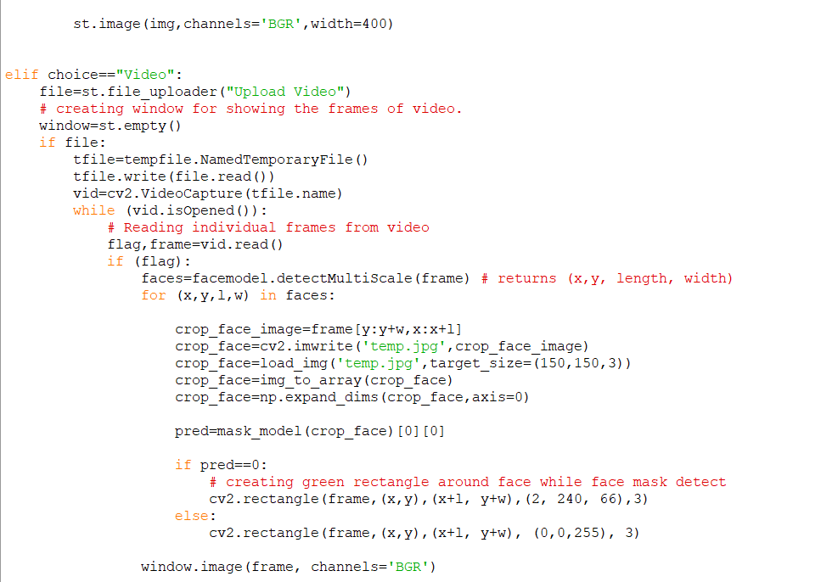

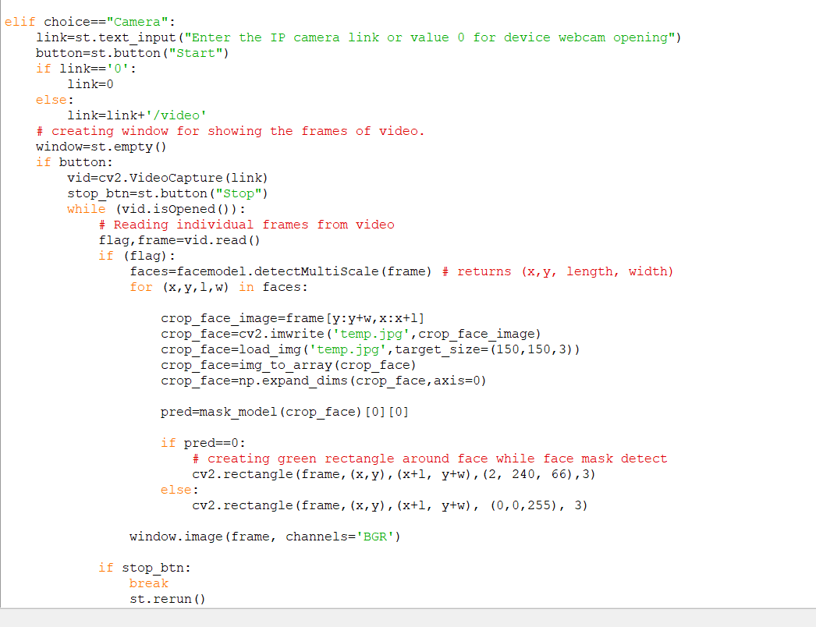

* Home Page

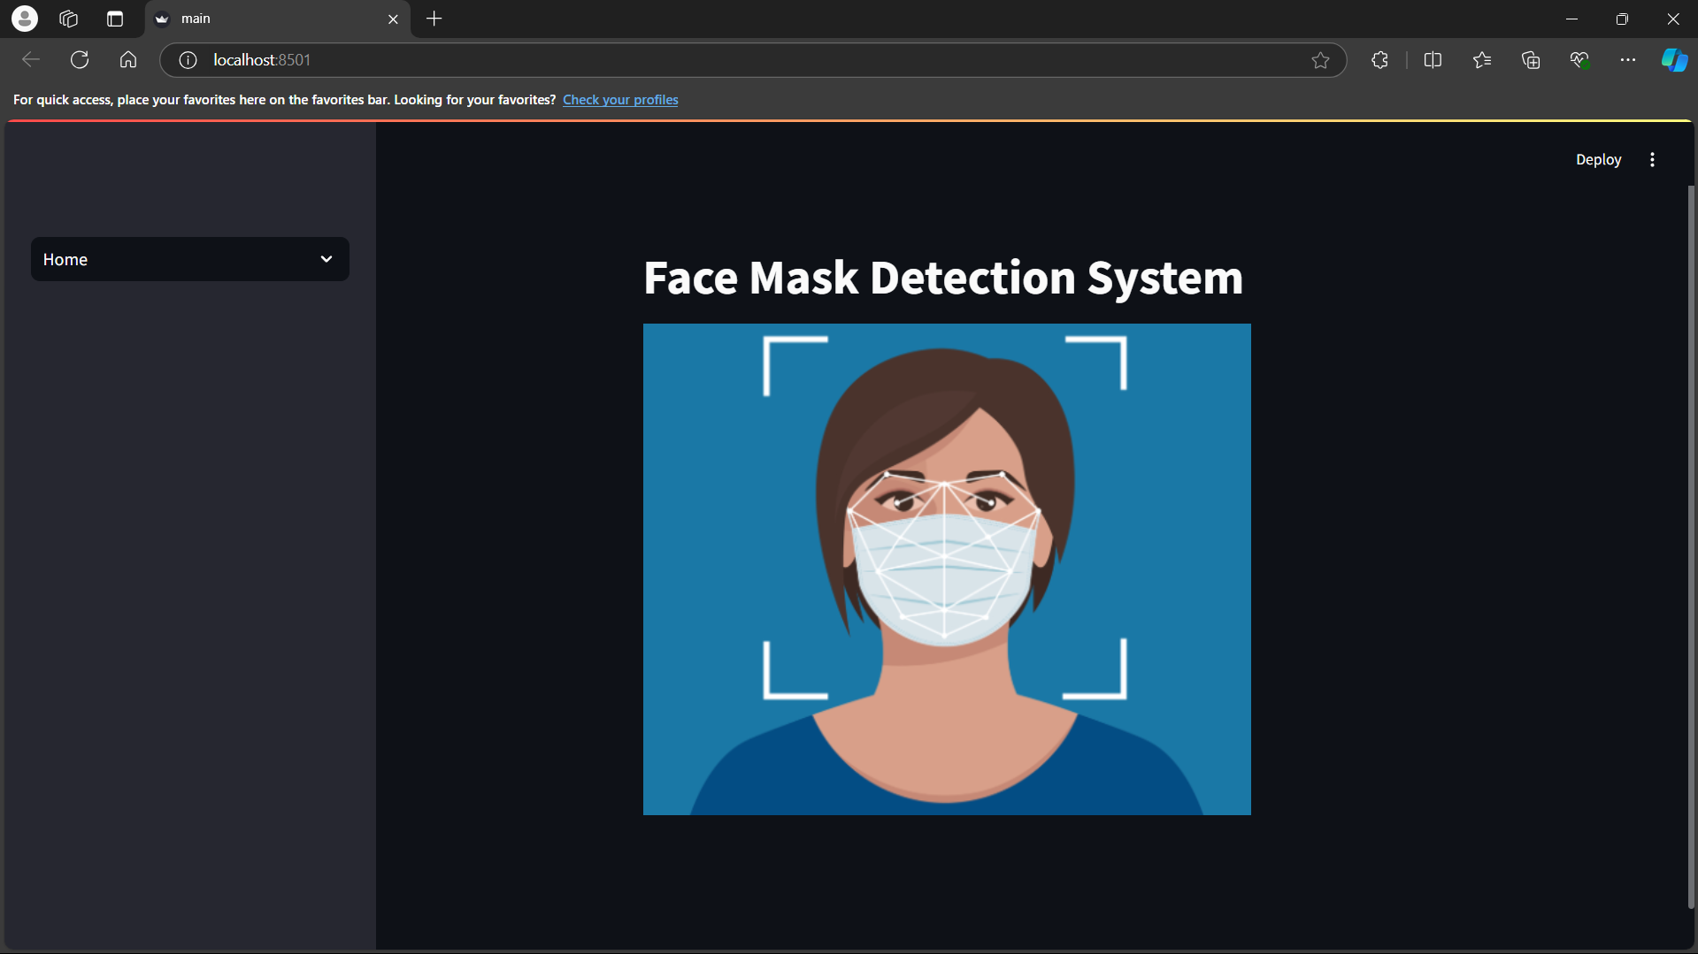

* Mask Detection from Image

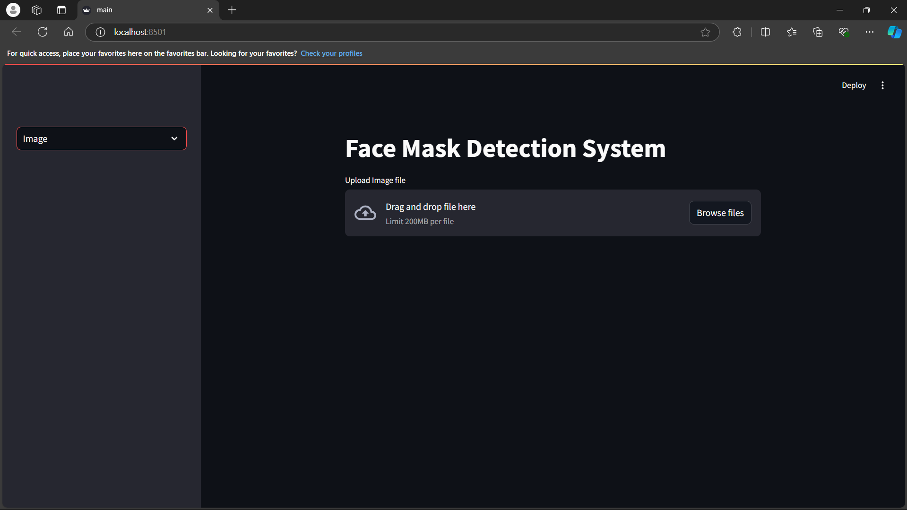

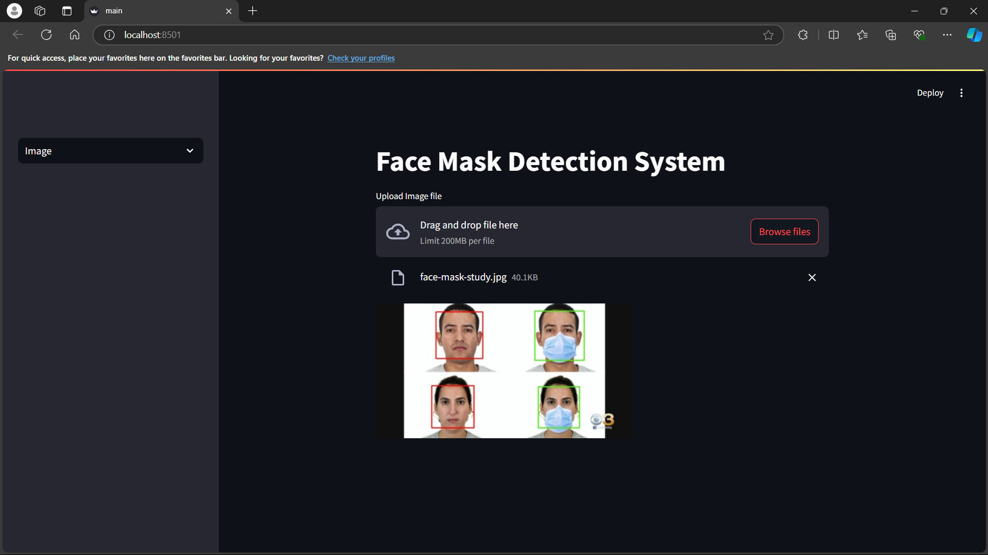

* Face Mask Detection from Video

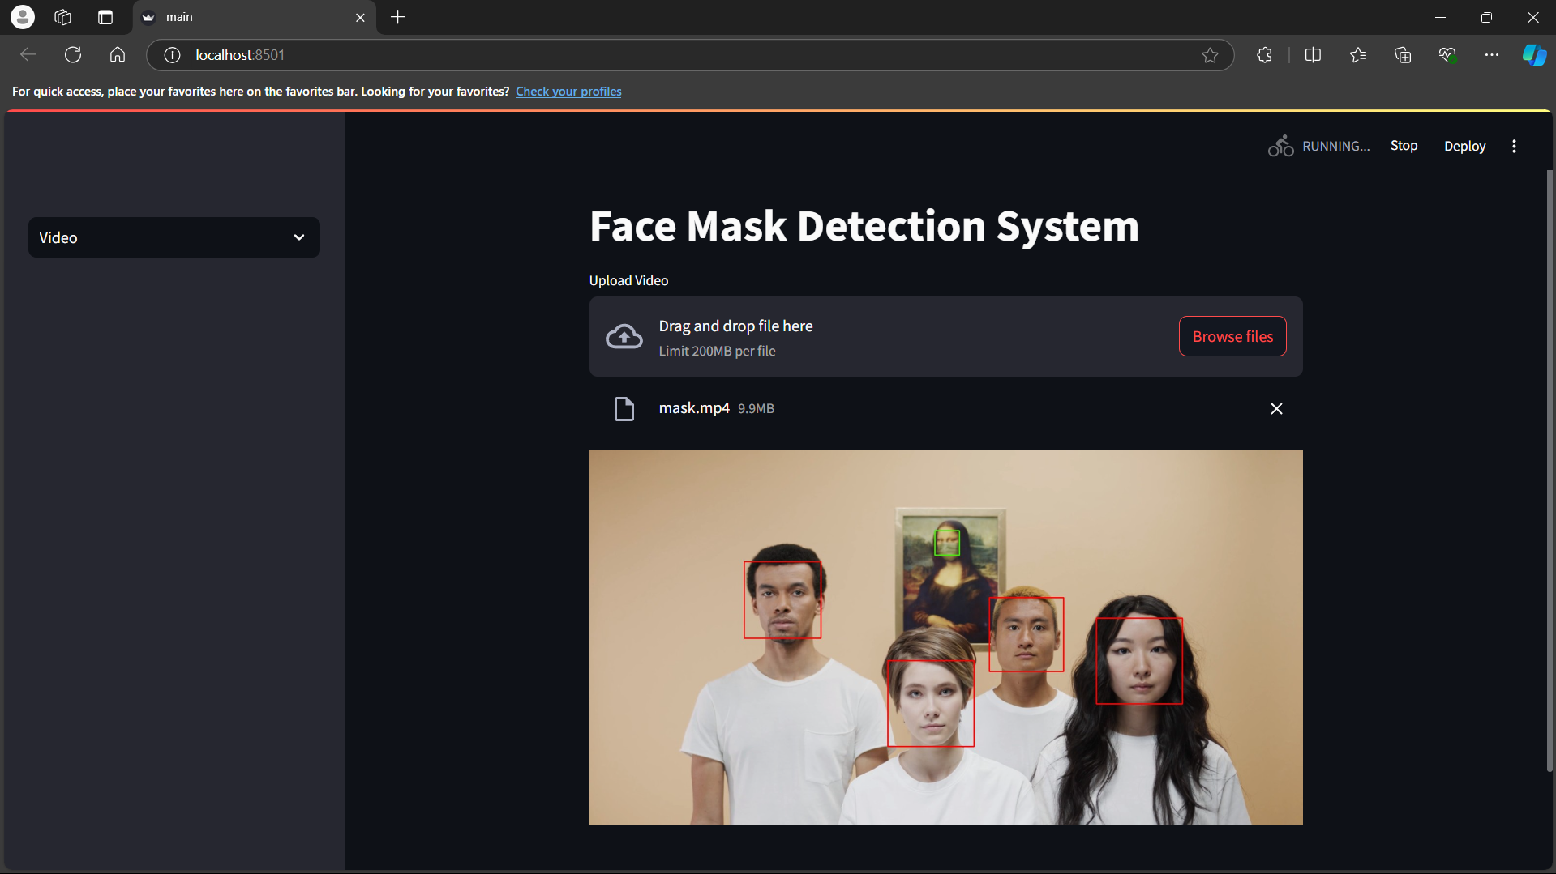

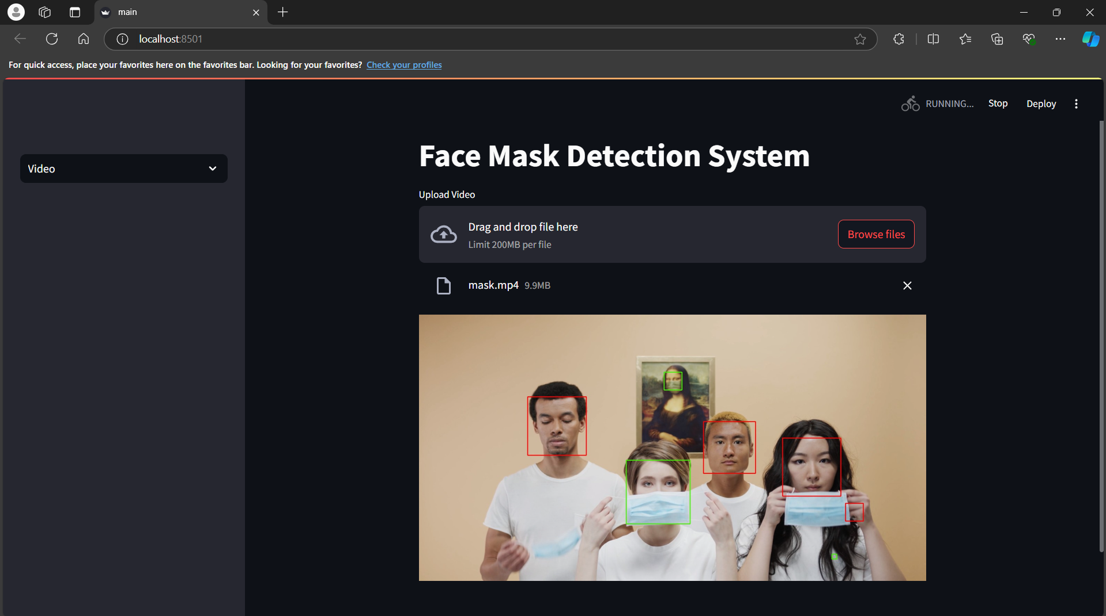

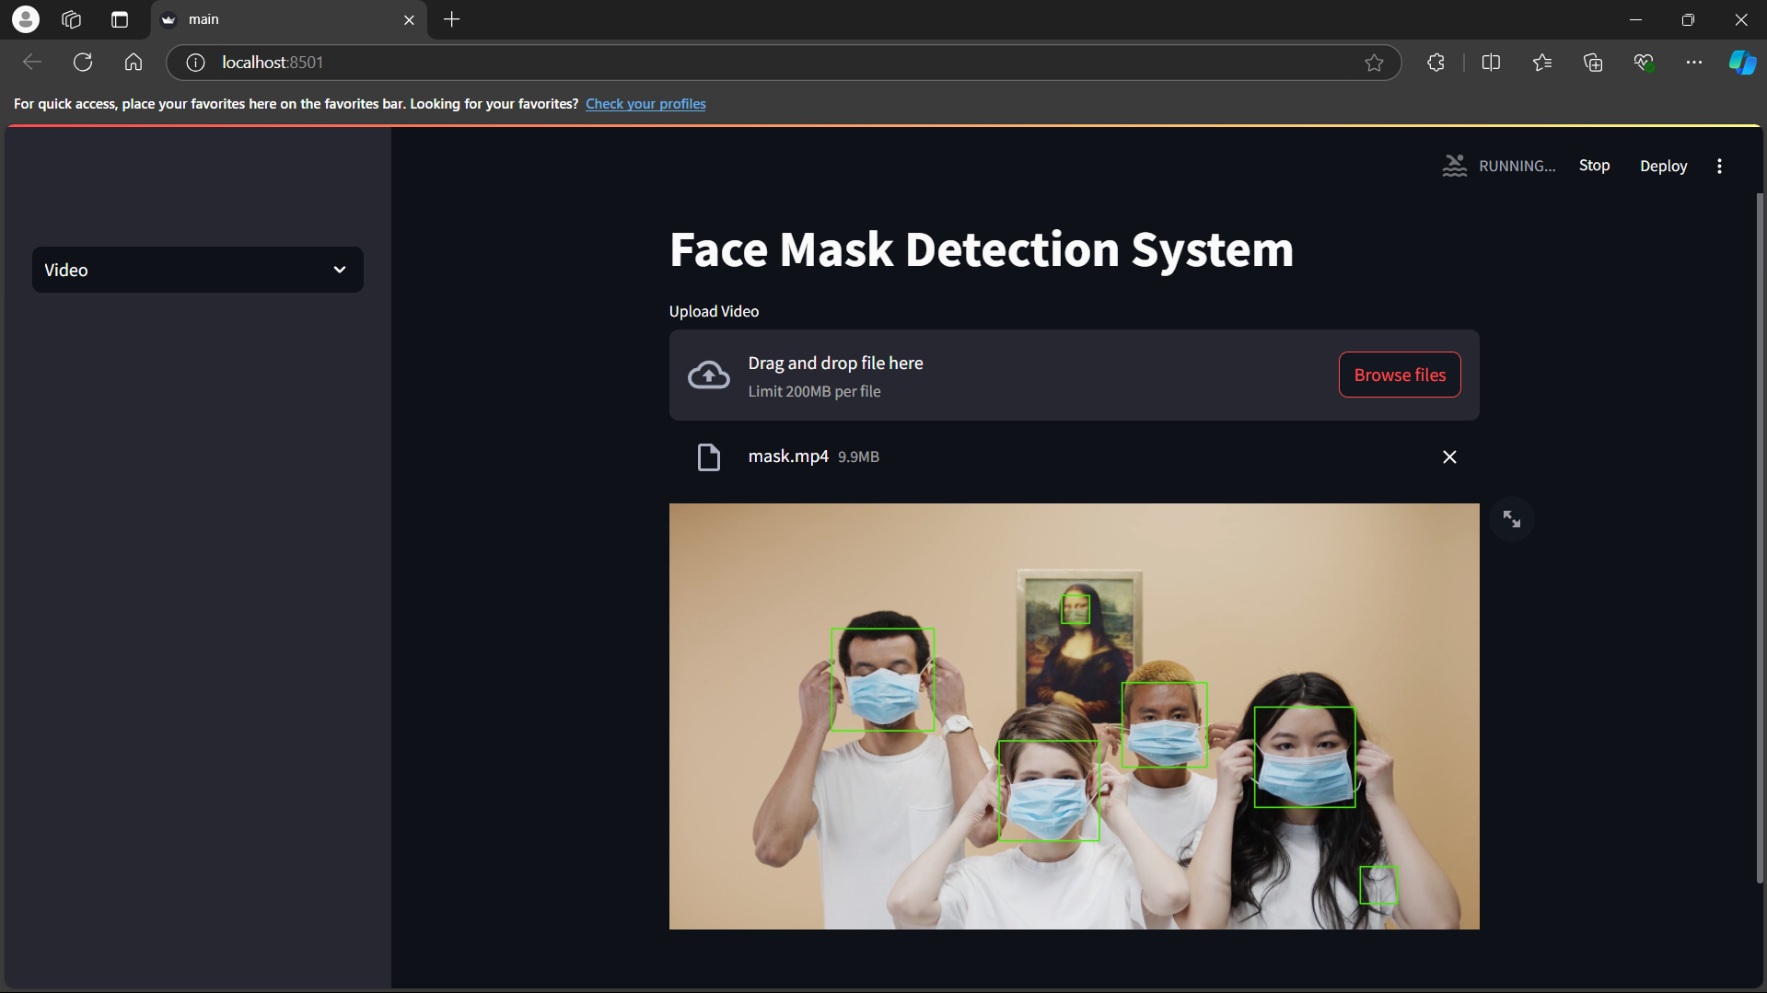

* Detecting Face mask using IP camera

